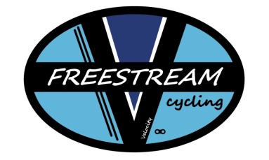
Freestream Cycling
Freestreamcycling@gmail.com
MINOR RELEASE (complete for participants under the age of 18)
AND I, THE MINOR'S PARENT AND/OR LEGAL GUARDIAN, UNDERSTAND THE NATURE OF BICYCLING ACTIVITIES AND THE MINOR'S EXPERIENCE AND CAPABILITIES AND BELIEVE THE MINOR TO BE QUALIFIED, IN GOOD HEALTH, AND IN PROPER PHYSICAL CONDITION TO PARTICIPATE IN SUCH ACTIVITY. I HEREBY RELEASE, DISCHARGE, COVENANT NOT TO SUE, AND AGREE TO INDEMNIFY AND SAVE AND HOLD HARMLESS EACH OF THE RELEASEES FROM ALL LIABILITY, CLAIMS, DEMANDS, LOSSES, OR DAMAGES ON THE MINOR'S ACCOUNT CAUSED OR ALLEGED TO BE CAUSED IN WHOLE OR IN PART BY THE NEGLIGENCE OF THE "RELEASEES" OR OTHERWISE, INCLUDING NEGLIGENT RESCUE OPERATIONS AND FURTHER AGREE THAT IF, DESPITE THIS RELEASE, I, THE MINOR, OR ANYONE ON THE MINOR'S BEHALF MAKES A CLAIM AGAINST ANY OF THE RELEASEES NAMED ABOVE, I WILL INDEMNIFY, SAVE, AND HOLD HARMLESS EACH OF THE RELEASEES FROM ANY LITIGATION EXPENSES, ATTORNEY FEES, LOSS LIABILITY, DAMAGE, OR COST ANY MAY INCUR AS THE RESULT OF ANY SUCH CLAIM.
MINOR'S NAME (PRINTED):_________________________ BIRTH DATE OF MINOR: ___ - ____ -____
SIGNATURE OF MINOR PARTICIPANT:_____________________________________________
PARENT/GUARDIAN NAME (PRINTED):____________________________________________
PARENT/GUARDIAN SIGNATURE (only if participant is under the age of 18):
______________________________________________________________________
ADDRESS: (Street) ________________________(City) _________________ (State)______ (Zip) ______ PHONE: (___ )________ DATE:__________________

